Setup & Firmware Uploading Guide
Smart Button

Assembly Guide

- Prepare the Board for programming by connecting it to Voltlink programmer
Use the connection cable provided with the Voltlink adapter to connect with the Voltlink connector marked Serial Programming as shown in the image below
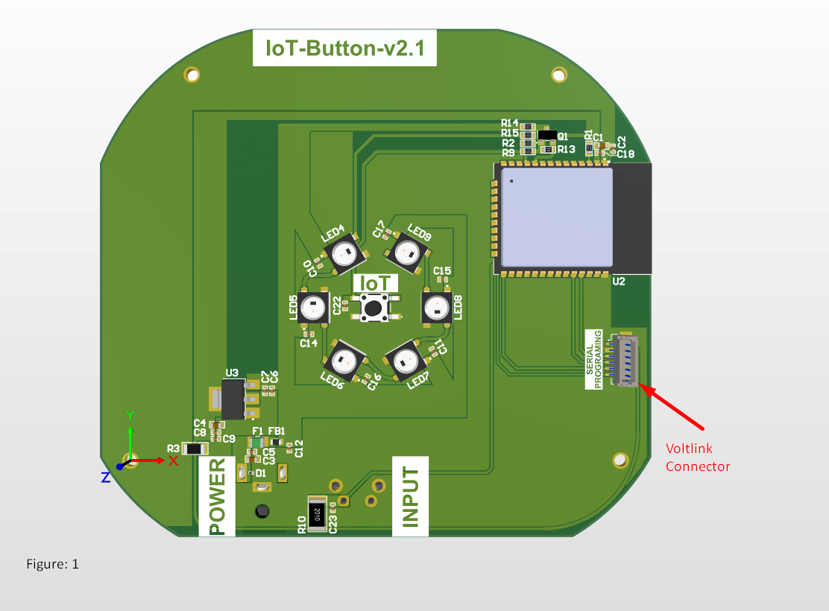
Power up Sequence
Insert the Type-C cable into the Voltlink programmer. Next power the Smart speaker board by connecting it with the provided 5V adapter make sure the DC barrel jack connector lead is center positive (+Ve).

